**Report**

**Chapter 1. Theory**

1. **What is the strain**

Strain is the amount of deformation of a body due to an applied force. More specifically, strain (ε) is defined as the fractional change in length, as shown in Figure 1 below.

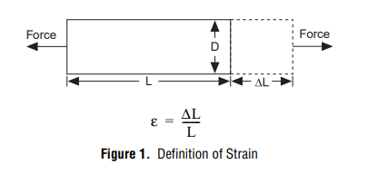

Strain can be positive (tensile) or negative (compressive). Although dimensionless, strain is sometimes expressed in units such as in./in. or mm/mm. In practice, the magnitude of measured strain is very small. Therefore, strain is often expressed as microstrain (µε), which is ε × 10–6. When a bar is strained with a uniaxial force, as in Figure 1, a phenomenon known as Poisson Strain causes the girth of the bar, D, to contract in the transverse, or perpendicular, direction. The magnitude of this transverse contraction is a material property indicated by its Poisson's Ratio. The Poisson's Ratio ν of a material is defined as the negative ratio of the strain in the transverse direction (perpendicular to the force) to the strain in the axial direction (parallel to the force), or ν = –εT/ε. Poisson's Ratio for steel, for example, ranges from 0.25 to 0.3.

1. **The strain gauge**

While there are several methods of measuring strain, the most common is with a strain gauge, a device whose electrical resistance varies in proportion to the amount of strain in the device. For example, the piezoresistive strain gauge is a semiconductor device whose resistance varies nonlinearly with strain. The most widely used gauge, however, is the bonded metallic strain gauge. The metallic strain gauge consists of a very fine wire or, more commonly, metallic foil arranged in a grid pattern. The grid pattern maximizes the amount of metallic wire or foil subject to strain in the parallel direction (Figure 2). The cross sectional area of the grid is minimized to reduce the effect of shear strain and Poisson Strain. The grid is bonded to a thin backing, called the carrier, which is attached directly to the test specimen. Therefore, the strain experienced by the test specimen is transferred directly to the strain gauge, which responds with a linear change in electrical resistance. Strain gauges are available commercially with nominal resistance values from 30 to 3000 Ω, with 120, 350, and 1000 Ω being the most common values.

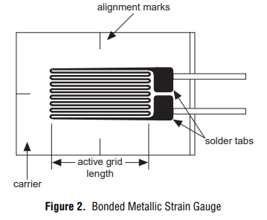

It is very important that the strain gauge be properly mounted onto the test specimen so that the strain is accurately transferred from the test specimen, though the adhesive and strain gauge backing, to the foil itself. Manufacturers of strain gauges are the best source of information on proper mounting of strain gauges. A fundamental parameter of the strain gauge is its sensitivity to strain, expressed quantitatively as the gauge factor (GF). Gauge factor is defined as the ratio of fractional change in electrical resistance to the fractional change in length (strain):

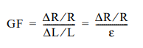

The Gauge Factor for metallic strain gauges is typically around 2

Ideally, we would like the resistance of the strain gauge to change only in response to applied strain. However, strain gauge material, as well as the specimen material to which the gauge is applied, will also respond to changes in temperature. Strain gauge manufacturers attempt to minimize sensitivity to temperature by processing the gauge material to compensate for the thermal expansion of the specimen material for which the gauge is intended. While compensated gauges reduce the thermal sensitivity, they do not totally remove it.

1. **Strain Gauge Measurement**

In practice, the strain measurements rarely involve quantities larger than a few millistrain (ε × 10–3). Therefore, to measure the strain requires accurate measurement of very small changes in resistance. For example, suppose a test specimen undergoes a substantial strain of 500 µε. A strain gauge with a gauge factor GF = 2 will exhibit a change in electrical resistance of only 2•(500 × 10–6) = 0.1%. For a 120 Ω gauge, this is a change of only 0.12 Ω.

To measure such small changes in resistance, and compensate for the temperature sensitivity discussed in the previous section, strain gauges are almost always used in a bridge configuration with a voltage or current excitation source.

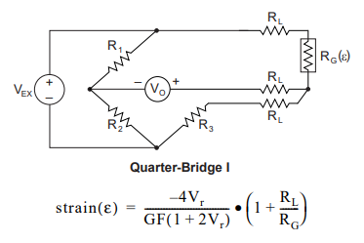

**Fig. 3**. Quarter-Bridge Circuit

* R1 is the half-bridge completion resistor.
* R2 is the half-bridge completion resistor.
* R3 is the quarter-bridge completion resistor, known as a dummy resistor.
* RG is the active strain gage element measuring tensile strain (+ε).
* VEX is the excitation voltage.
* RL is the lead resistance.
* V0 is the measured voltage.
* GF is the gage factor
* Vr is the voltage ratio that virtual channels use in the voltage-to-strain conversion equation

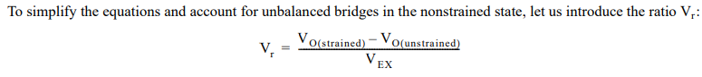

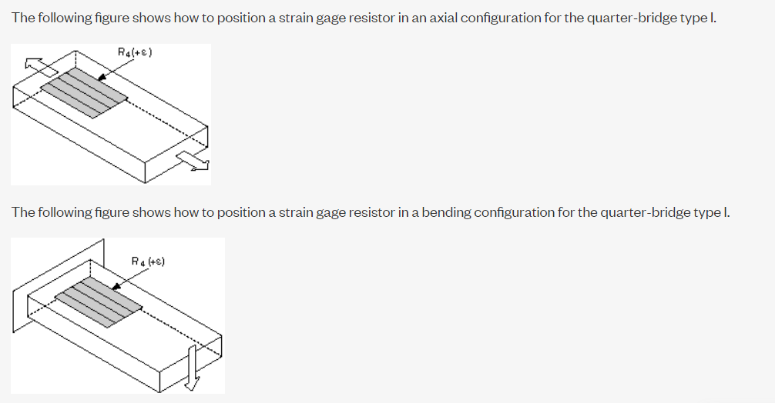

1. **Signal Conditioning for Strain Gauges**

Bridge Excitation – Strain gauge signal conditioners typically provide a constant voltage source to power the bridge. While there is no standard voltage level that is recognized industry wide, excitation voltage levels of around 3 V and 10 V are common. While a higher excitation voltage generates a proportionately higher output voltage, the higher voltage can also cause larger errors due to self-heating. Again, it is very important that the excitation voltage be very accurate and stable. Alternatively, one can use a less accurate or stable voltage, and accurately measure, or sense, the excitation voltage so the correct strain can be calculated.

Signal Amplification – The output of strain gauges and bridges is relatively small. In practice, most strain gauge bridges and strain-based transducers will output less than 10 mV/V (10 mV of output per volt of excitation voltage). With a 10 V excitation voltage, the output signal will be 100 mV. Therefore, strain gauge signal conditioners usually include amplifiers to boost the signal level to increase measurement resolution and improve signal-to-noise ratios.

SCXI signal conditioning modules, for example, include configurable gain amplifiers with gains up to 2000.

**Chapter 2. Experiment and simulation**

**2.1. Experiment**

An experiment was carried out to measure Strain on a beam using a Strain gauge. Data collection and analysis were performed by DAQ National Instrument and LabVIEW 9. Below is the equipment used to carry out the experiment.

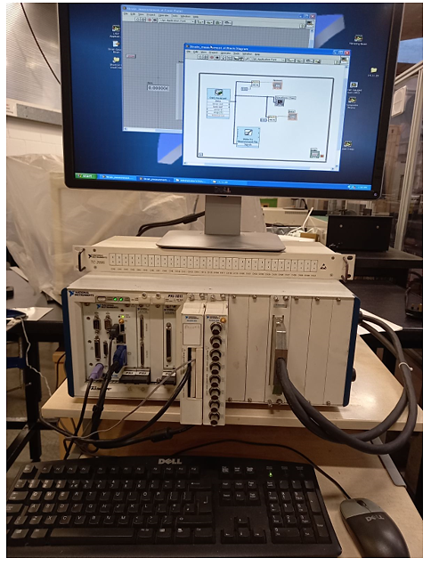

**Fig. 4.** Data acquisition system

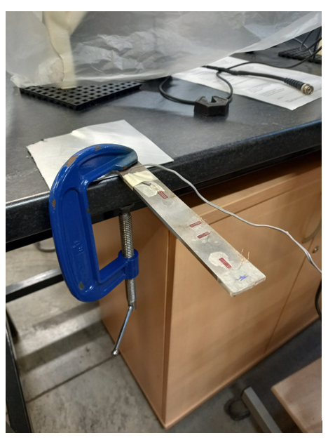

G Clamp

Beam

Place for loading by dead weights

Strain sensor under study

**Fig.5.** Set-up for loading beam

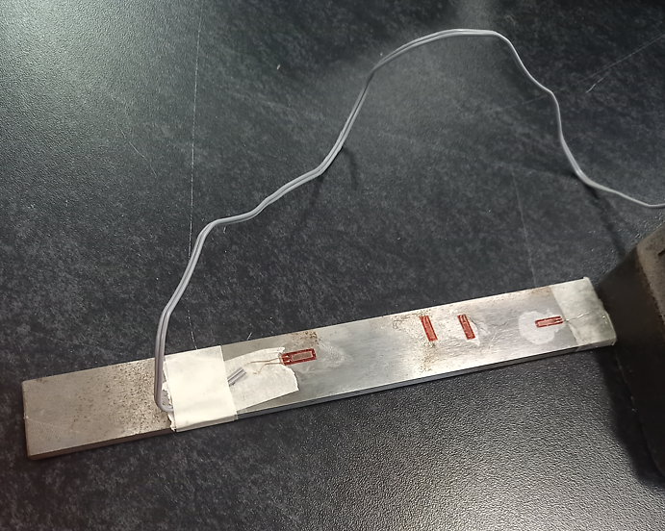

Strain gauge used for the experiment

**Fig.6.** Beam with four strain gauges

86

7

2.5

13

9

**Thickness** – 4 mm

25

12

15.5

195

**Fig. 7.** Sketch of the beam with glued strain gauge

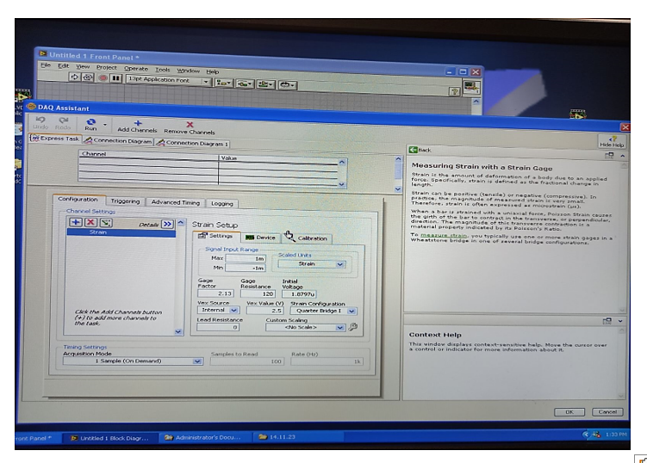

**Fig. 8.** Screen of DAQ Assistant settings

Gage factor – 2.13 (specified on the box with gauges)

Gage resistance – 120 Ohm(Ω) (specified on the box with gauges)

Lead resistance – 0 Ohm

Strain configuration – Quarter Bridge I

Vex source – internal (Rob said)

Vex value – 2.5 V (Rob said)

Input voltage – 1.8797u (this value appears after calibration – we have done the calibration as in the video 1)

**Data for initializing DAQ**

Physical channel - **SCXI-1520** universal strain/bridge module

ai **5** port

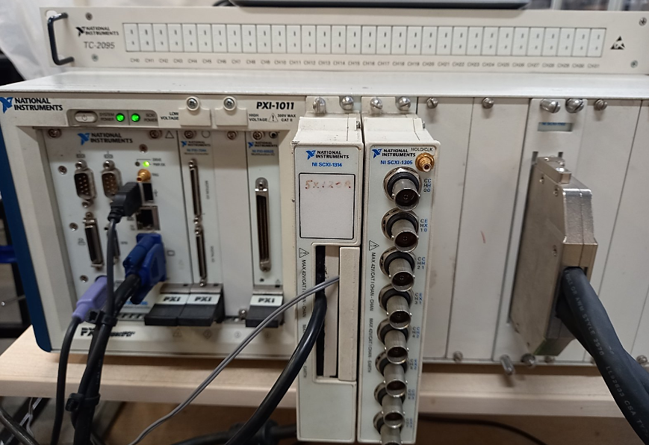

PXI 1011 chassis

SCXI -1314

**Fig**. 9. SCXI -1314 UNIVERSAL STRAIN TERMINAL BLOCK

**Signal Conditioning eXtensions** for Instrumentation (SCXI) is a signal conditioning and data acquisition system for PC-based instrumentation applications. An SCXI system consists of a shielded chassis that houses a combination of signal conditioning input and output modules, which perform a variety of signal conditioning functions. You can connect many different types of transducers, including strain gauges, directly to SCXI modules. The SCXI system can operate as a front-end signal conditioning system for PC plug-in or PCMCIA data acquisition boards. Alternatively, you can use an SCXI data acquisition module that digitizes the analog signals and connects directly to the parallel port of the PC.

The **SCXI-1314 terminal block** is used with the SCXI-1520 universal strain/bridge module enabling you to conveniently connect strain gauges through screw terminals. There are 88 screw terminals arranged in eight groups of 11. Each group corresponds to one of the eight channels available on the SCXI-1520.

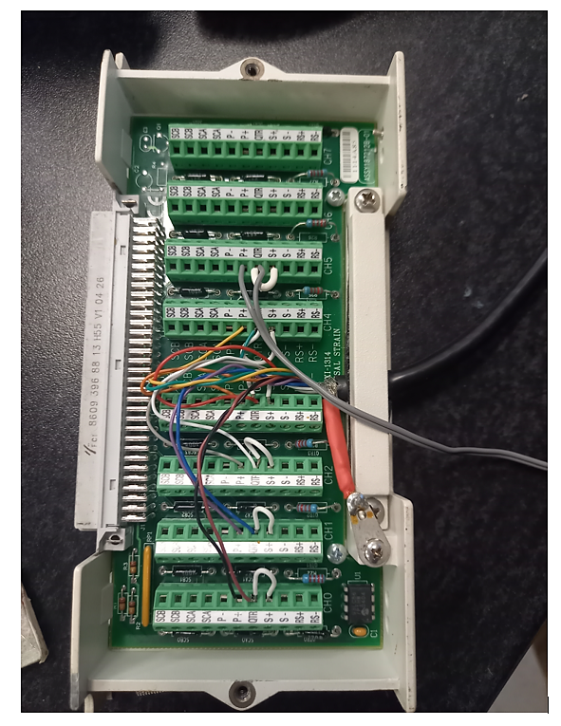

ai **5** port

11 terminals

**Fig.** **10**. SCXI -1314 UNIVERSAL STRAIN TERMINAL BLOCK (Inside view).

SCXI -1314 module

SCXI-1520 module

**Fig.11.** SCXI-1520 module

8-Channel Strain/Bridge Input Module for SCXI—The SCXI‑1520 is a strain/bridge input module. You can configure the module settings on a per channel basis for maximum flexibility in test cell applications measuring strain, force, torque, or pressure sensors. The SCXI‑1520 can measure strain gauge configurations including quarter‑, half‑, and full‑bridge configurations. This module features software-selectable voltage excitation, multiple lowpass filters, and over 40 input gain settings. You also need either **the SCXI‑1314** or SCXI‑1314T front mount terminal block to use the SCXI‑1520.

Average value 3.49·10-4

5 kg

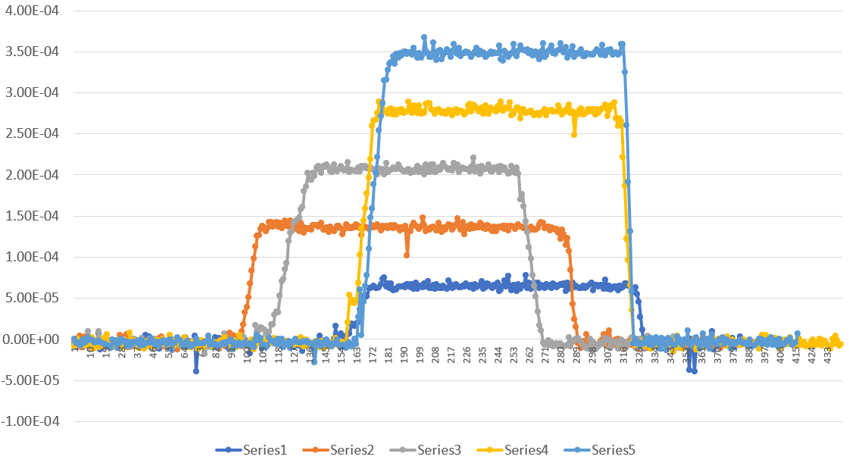

4 kg

3 kg

2 kg

1 kg

**Fig.12.** Beam loading graphs

**2.2. Simulation**

Let's perform modeling in ANSYS and SolidWorks.

**Рlace of application of force**

**Point for strain determination**

86

7

13

**Thickness** – 4 mm

25

12

15.5

**Fixed geometry on the bottom**

195

**Fig.13.** Sketch of the beam with point in the middle of the strain gauge for simulation

**a**

**B**

**Fig.14.** Screen 3D model of the beam

**Fig.15.** Screen 3D model of the beam with simulation conditions

**Fig.16.** Strain field (Force 9.81 N)

**Fig. 17.** Strain field (Force 9.81 N)

**Fig. 18.** Strain field (zoom) with Strain value

**Chapter 3. Comparison of the results**

Let's compare modeling results in Solidworks and ANSYS.

**Table 2. Numerical and experimental results**

|  |  |  |  |  |  |  |
| --- | --- | --- | --- | --- | --- | --- |
| **m, kg** | **Force, N** | **Simulation** | | **Experiment** | **Error, %**  **Solidworks** | **Error, %**  **ANSYS** |
| Solidworks | ANSYS |
| 1 | 9.81 | 5.497·10-5 | 6.49·10-5 | 6.45·10-5 | 15 | 0.62 |
| 2 | 19.62 | 1.083·10-4 | 1.30·10-4 | 1.36·10-4 | 21 | 4.41 |
| 3 | 29.43 | 1.625·10-4 | 1.95·10-4 | 2.07·10-4 | 22 | 5.80 |
| 4 | 39.24 | 2.219·10-4 | 2.60·10-4 | 2.78·10-4 | 20 | 6.47 |
| 5 | 49.05 | 2.632·10-4 | 3.24·10-4 | 3.49·10-4 | 25 | 7.16 |

**Conclusions**

1. An experimental strain measurement on the beam was carried out using a strain sensor 120 Ohm.

2. Modeling in Solidworks and ANSYS is performed.

3. The difference between the experimental and simulation results ranges from 0.62 to 7.16% for ANSYS and from 15 to 25% for Solidworks. Moreover, the difference increases with increasing applied load.

**Useful videos**

**Measurements I - 1/4 Bridge Strain Guage LabView Tutorial**

<https://www.youtube.com/watch?v=itJxmz5AOOw>

**NI Signal Express and Strain Gauge Connections with NI 9237 and NI 9949**

<https://www.youtube.com/watch?v=WAJJxSgv9xA>

# NI instrument and LabVIEW tutorial : read strain signal

[**https://www.youtube.com/watch?v=xga2Bt_nwbo**](https://www.youtube.com/watch?v=xga2Bt_nwbo)

**Applying point load in Solidworks**

<https://www.youtube.com/watch?v=gHwgOF2LCek>